Available now:
******
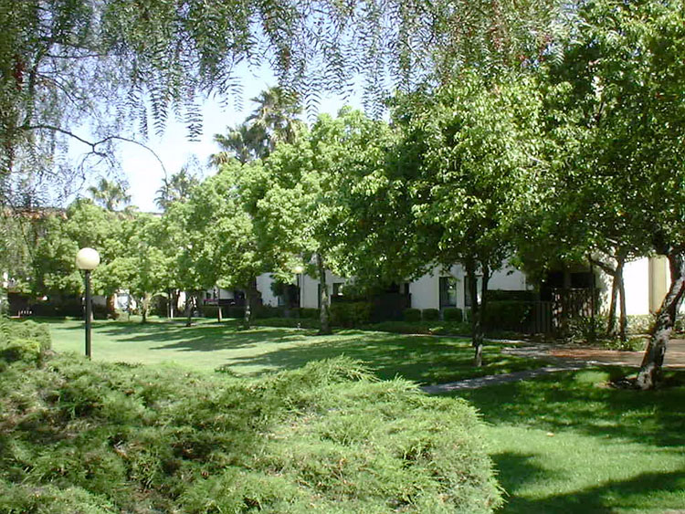
39997Cedar Blvd. #253
Newark, CA 94560
- 3 Bedroom, 2 Bath
- Facing inside courtyard
- Rent
• $150o/mo. rent
• $1500 deposit
• Water / garbage included
• Owner to pay HOA dues
• Non-smoking home
- Unit has refrigerator, dish washer, dryer, washer, water heater
- Excellent condition, well maintained by current tenants
- Available Sept.10, onwards
- Contact for viewing: Tel. 925 426 9160, rpopli@comcast.net

